**CARINA**

DEVELOPER STARTUP GUIDE

**NetBeans IDE and XAMPP**

If you do or don’t have NetBeans IDE and XAMPP set up already, this web page was found to be extremely useful and help explain the basics. I had some trouble with J

<http://www.guru99.com/xampp-netbeans.html>

There are very good sources on Linux and Mac OS also, but this guide will just be windows.

Be sure you have no errors and XAMPP and you will only need to start and stop the Apache and MySQL modules. If you have problems/errors, there are plenty of forums on how to get it going. I had to overcome a port conflict.

I suggest getting to know the XAMPP dashboard. There is lots of valuable info and toolds to be had under the config, log. I don’t use them a lot anymore, but good to understand.

**Project in NetBeans**

**Put the project here like this**

**C:\xampp\htdocs\CARINA**

There is a copy of the baseline here on dropbox and I emailed a zip file of it too.

**Dropbox\SeniorDesign\CARINA NETBEANS\**

If you want to CLONE the baseline from bitbucket while in NetBeans,

First go to the bitbucket repository on the internet:

<https://bitbucket.org/account/signin/> **username**: carina_project **password**: carina#AA!

You don’t have to do anything there, just get familiar with it. There is a tutorial system and you use the username and password below.

**NOTE**: I renamed the repository since my group e-mail on 11-JAN-2015 at 2030 hours.

Open NetBeans

**Team > Git > Clone**

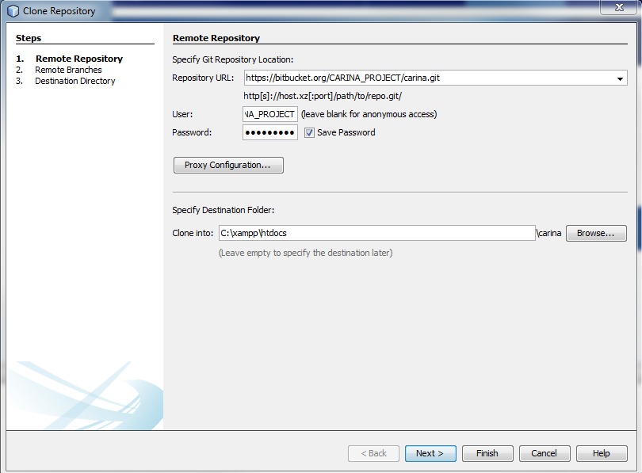

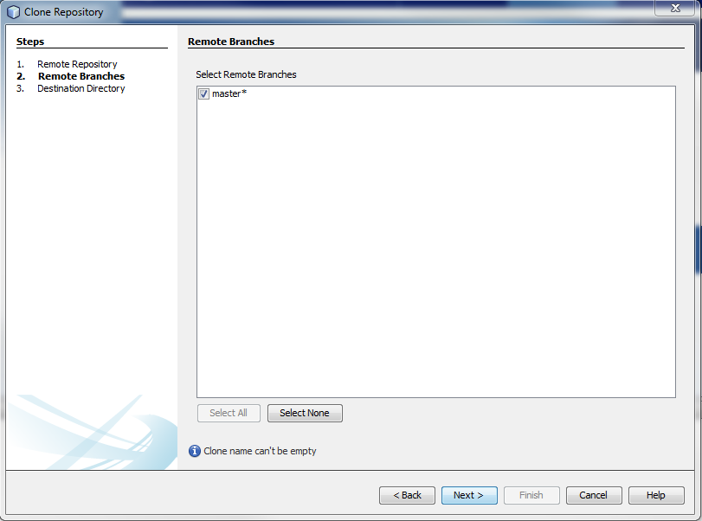

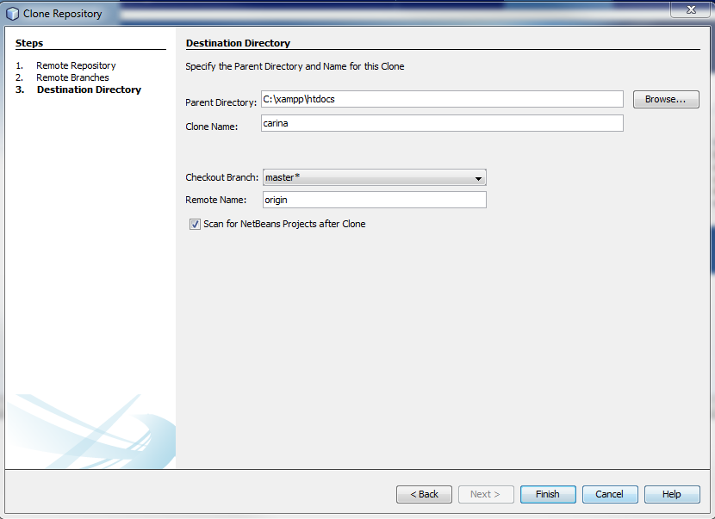

Click finish and NetBeans will start the cloning process from the BitBucket web repository.

NetBeans will prompt you with a CLONE Completed window, you can select Favorites and open project. Here is what mine looks like at this time.

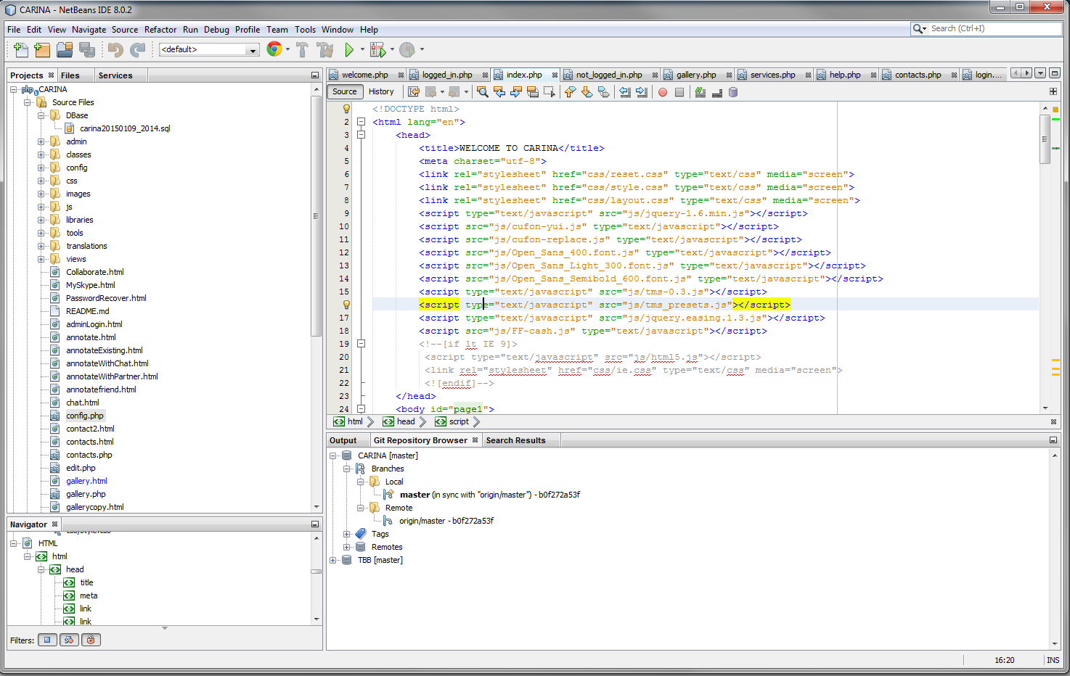

To integrate with NetBeans with bitbucket:

**Team > Git > Initialize Repository**

This integration area takes much more detailed instructions than what we want to do here so far but it is good to do at this time.

**phpMyAdmin and DataBase Import**

This is the most awesome tool I have ever seen for manage data bases. If you have any previous experience with SQL databases, this is the BOMB!

This phpMyAdmin package came along with XAMPP.

Simply start it up in your web browser with:

localhost/phpmyadmin

Very well done tutorial here:

<http://www.siteground.com/tutorials/phpmyadmin/>

and lots of documentation here

http://localhost/phpmyadmin/doc/html/index.html

Once you are in phpMyAdmin, use the Databases tab, click New in the upper left, give it the name, **carina**, in the Collation window select **utf8_general_ci**

Got to the **Import** tab, browse to

C:\xampp\htdocs\CARINA\Dbase

And select the database **carina20150109_2014.sql**

Click **Go (all the way at the bottom):**

If prompted, the username is **root** and the password is **blank**

Should see the tables now in the tree under **carina**

This will be like the method we will use to update the database and transport to each other.

**TO UPDATE Database with new release**

Each time we update the database we must delete the current carina database in your phpMyAdmin. In phpMyAdmin, click **carina** database in the tree on the left. Then click the **Operations** tab, you can see the “Drop the database (DROP)” click and confirm and repeat the instructions in the section above.

**Connect NetBeans to Database**

Go to this area of NetBeans, right click the highlighted item **jdbc:mysql,** select connect.

When connect, the little icon will not be broken like the one just above it.

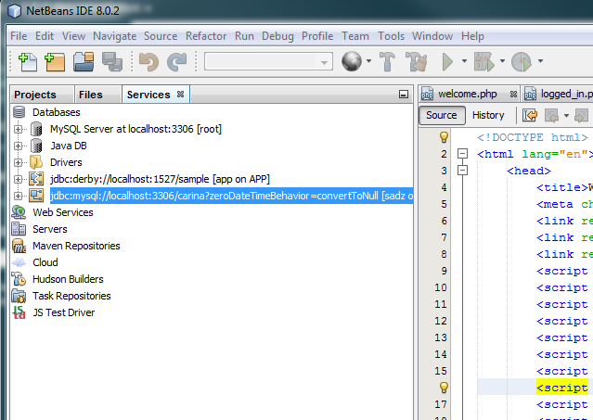

**Run Project**

Select CARINA as in the snap shot below; be sure to be in the Projects or Files Tab.

Click the green arrow in the toolbar and should run.

Navigate to register new account and submit.

You should get confirmation e-mail from [**carinaUNM2015@gmail.com**](mailto:carinaUNM2015@gmail.com)**, (created just for us!)**

See line 75 in the module below for the specification on the e-mail account

C:\xampp\htdocs\CARINA\config\config.php

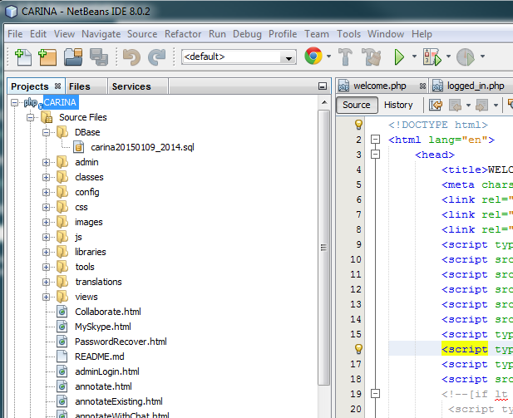

**NOTES**

NetBeans is very powerful and as I have used it the last month, found that it can really do some cool things to help code.

You will see a number of new php files that are like the html files.  Some html files are now dormant.

I have not deleted any files since the prototype we demo'd.  I've kept those modules in for the integration process of the log in system and for source code resource until we decide to delete anything.

Any deleted files will be retained in bitbucket and also in the local repository as you learn to use it.  I am keeping an archive on my home pc also for a safety net.

Added two parts of the Properties for reference:

**SOURCES**:

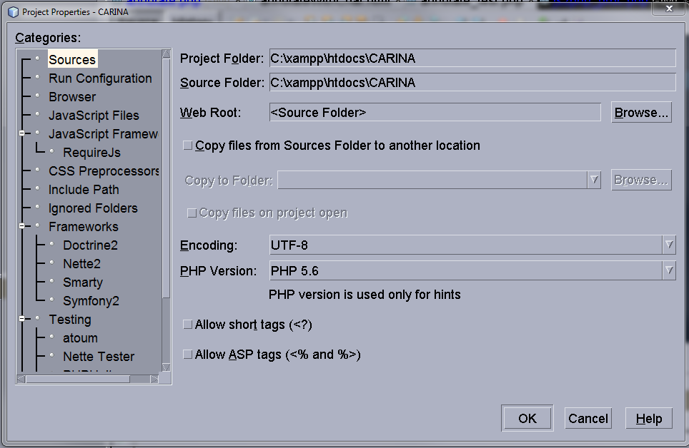

**RUN CONFIGURATION**

